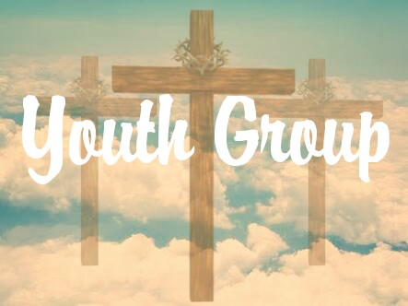
“Dear young people let yourselves be taken over by the light of Christ, and spread that light wherever you are.” - Saint John Paul II
A youth group is a chance for those involved to enter more deeply into their faith and encounter Christ in new ways. It allows those involved to develop strong faith filled friendships which can last for many years.
All are welcome from Year’s 5 and 6, Ages 11 - 12
The youth group will be a monthly event, on the first Friday of every month. These events will be announced at the weekend Masses prior to the event.
The next event is:
First Friday of the coming month at 5.30pm – 6.30pm.
Held at Hope and Harmony Hall, St Raphael’s Primary School, 82 George St, South Hurstville
Looking forward to seeing you at our next event
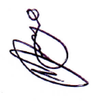
Natalie Prego

Mater Dei & St Raphael’s Parish Youth Minister
E: natalie-prego@hotmail.com
General Information:
Please Return to Natalie Prego on Friday, 1st of July
Child Information:
First Name: |  | Surname:
Preferred Name: (If different from above):

Date of Birth: | Age: |  | Schooling Year:
Primary School Attending:

If applicable; High School/s inconsideration:

Medical History:
Any Allergies:

Any Special Requirements:

Parent/ Guardian Information:
Parent/Guardian 1: | First Name: |  | Surname:
Relation: | Best Form of Contact:
Email:

Parent/Guardian 2: |  | First Name: | Surname:
Relation: | Best Form of Contact:
Email:

Would you like to be informed on each event your child will be involved in? (Please Tick) Yes / No

If yes, via: Print / Email

If needed, would you volunteer your time to supervise/ chaperone an event when assistance is required? (Please Tick) Yes / No

Parent/ Guardian Name:_____________________________________
Signature:_______________________ Date:___________________

