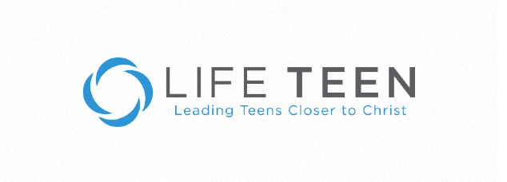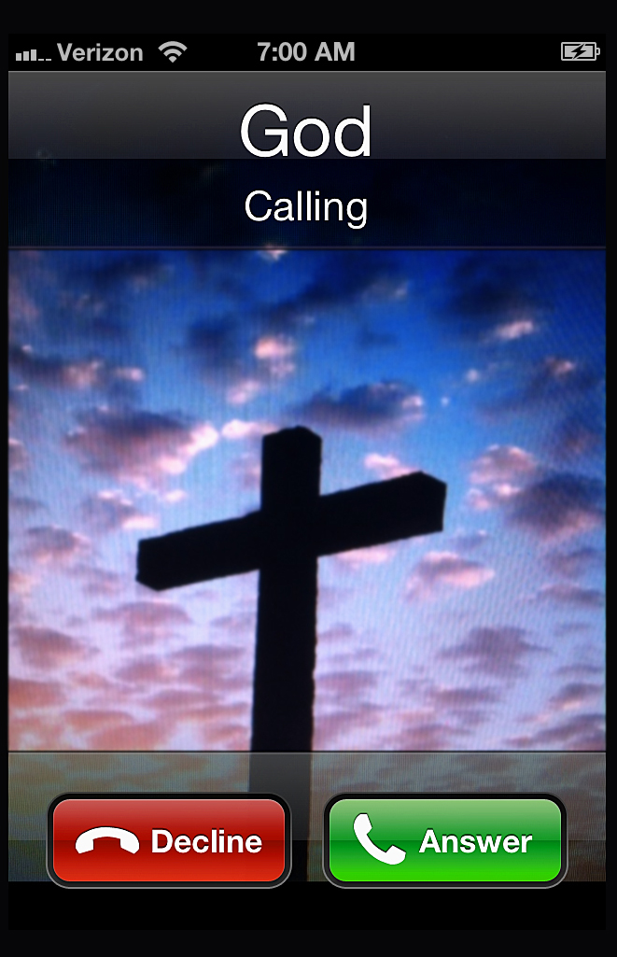

**Mater Dei**

**St Raphael Parish**

***We are calling children starting from the age of 11 to come and grow within the Catholic Faith.***

***To develop as well rounded, community based young adults.***

***For more information please contact:***

***Michael Fernandes on: 0437517758 or mc@materdei-straphael.org.au***

***Natalie Prego on: 0434614269 or natalie-prego@hotmail.com***

**YOUTH GROUP**

&